# Model Design:

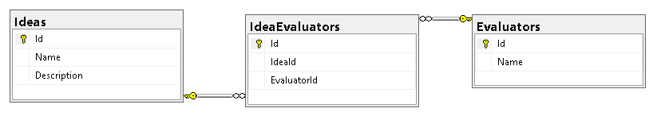

**Idea**: Master Table of Ideas

**Evaluators**: Master Table of Evaluators

**IdeaEvaluators:** Transaction Table has list of Ideas which are assigned to 3 Evaluators.

# Ui Design:

## Create Workload:

Create 20 Ideas and 10 Evaluators. As each idea can be assigned to 3 Evaluator (Judge).

Before creating workload **Table Records Count**:

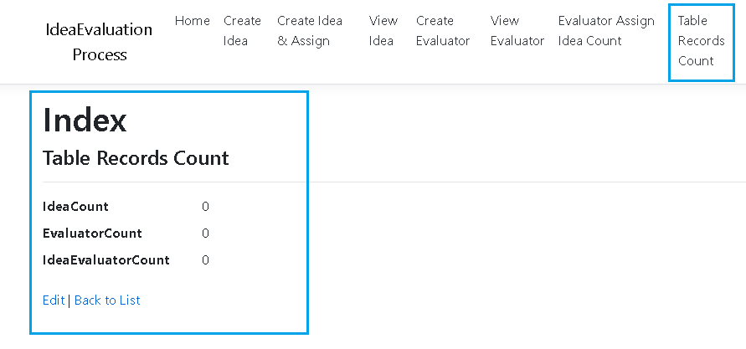

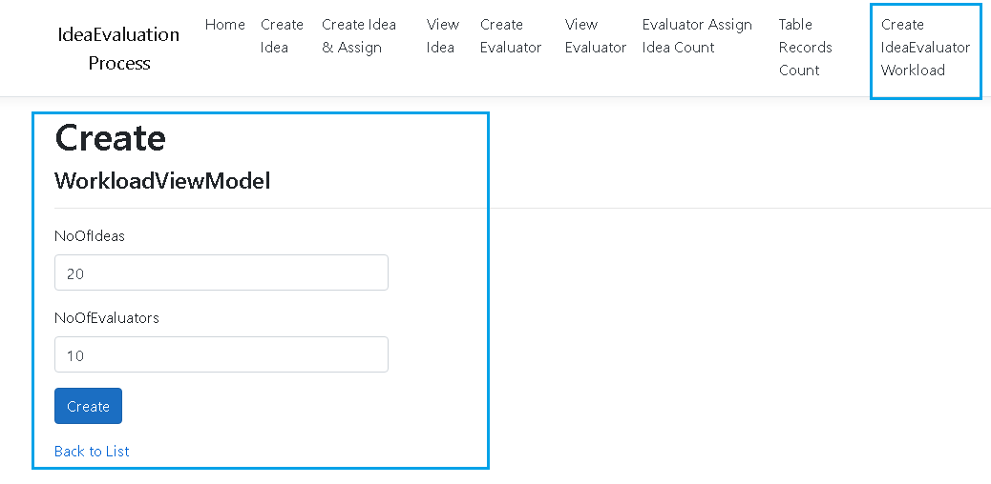

Table Record Count after workload creation:

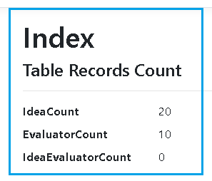

## Assign Workload:

Before assigning workload each evaluator record count:

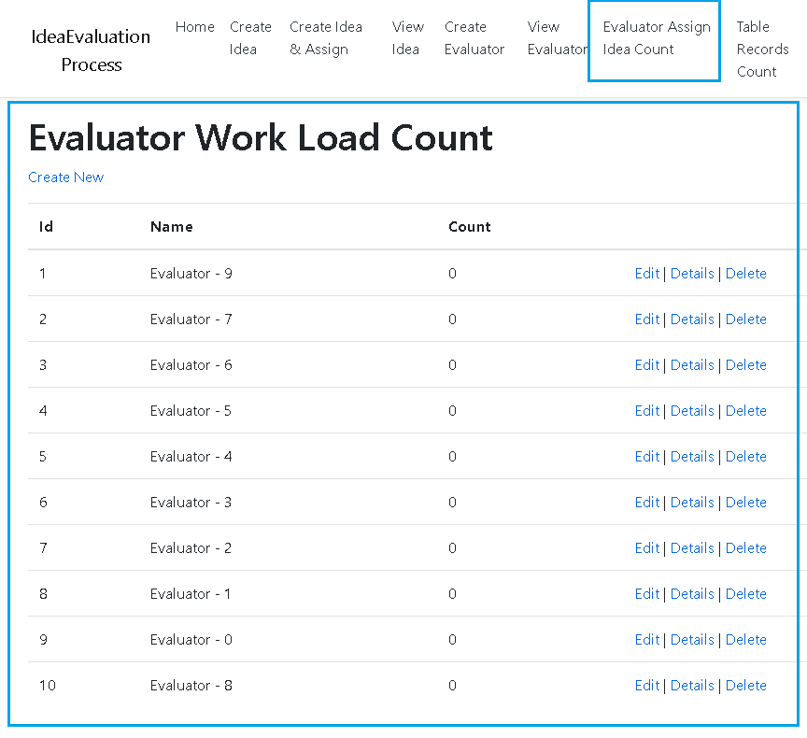

## Process & Assign Workload

**Click on Process Workload:**

This will look for all ideas and assign each idea to 3 evaluators(judge).

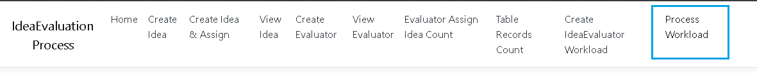

**Verify workload:**

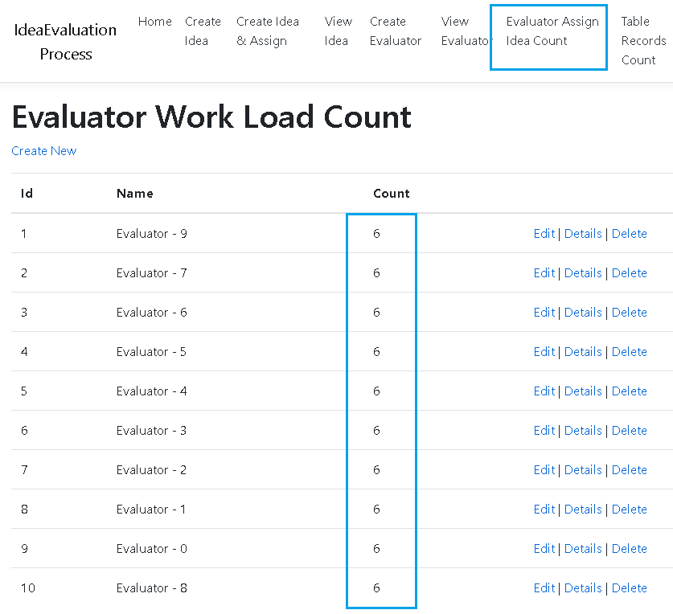

**Verify Table Count:**

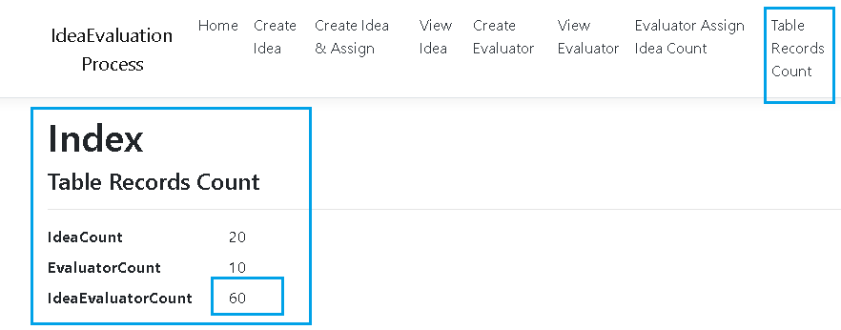

## Realtime individual Idea Assignment:

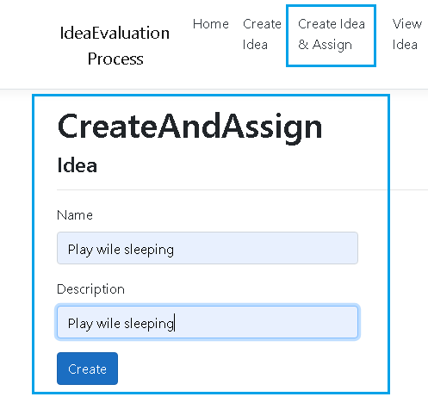

**Verify Count:**

This will ensure new realtime Idea assign to specific 3 Evaluator based on the load.

